E Commerce Project Technical Documentation
Title of the Project: Avela: A Hair Care E-Commerce Application with Hair Profile Assessment and Routine Building
Project Members: Aleckzandra T. Bahillo, Jasmine Iris Eva, Alexzis Mae E. Tutor, Angela Nicole V. Zurbano
Instructor: Prof. Samantha D. Siao, MSIT
Course: Open-Source Programming with Database
Semester/School Year: First Semester, 2026-2027

I Introduction
Avela is a haircare e-commerce application developed for the Open-Source Programming with Database and Information Assurance and Security coursework. It combines product shopping with a structured hair assessment, explainable product matching and a suggested care routine. Customers can understand why a product appears in their results while shopping through the same catalog, bag and checkout used elsewhere in the store.
The project addresses two connected tasks: helping customers organize their haircare choices and giving staff controlled tools to maintain products, inventory, accounts and orders. This document describes the implemented PHP application, its relational database, interfaces, security controls and turnover procedure. The deployed public entry point is https://avela.onrender.com/.

II Project Description
The application serves three roles: Customer, Catalog Manager and Administrator. Customers browse and purchase products and maintain their own profiles. Catalog Managers maintain catalog and inventory data. Administrators oversee accounts, security settings, activity and operational reports. Server-side role and ownership checks apply independently of which navigation links are visible.

Features
• Customer registration with reCAPTCHA, email verification and a single-use activation link; password sign-in and optional authenticator enrollment.
• Product catalog with search, category and suitability filters, sorting, product details, favorites, ingredient references and stock-aware purchase controls.
• Persistent bag drawer, quantity changes, unavailable-stock feedback, saved delivery addresses, shipping quotes, discounts and transactional checkout.
• Cash on Delivery and guarded Maya-hosted Sandbox card-payment flows, with order references, receipts, email delivery queue and fulfillment history.
• Five-step hair assessment covering texture, scalp, lengths and habits, optional concern text and review before saving.
• Bounded runtime Python concern interpretation, evidence-filtered product matching with explicit reasons and a personalized wash-day and between-wash routine.
• Catalog Manager product/category CRUD, image handling, archive/reactivation and concurrency-aware stock updates.
• Administrator account management, lockout controls, password policy, activity/audit views and dashboard reports.

Technologies Used
Layer | Implementation
Frontend | Server-rendered HTML, CSS, vanilla JavaScript, local fonts and responsive layouts
Backend | Native PHP 8.2+ with custom MVC-style routing and Composer-locked libraries
Database | MySQL/MariaDB, InnoDB transactions, foreign keys and PDO prepared statements
Personalization | Python 3.10+ standard-library interpreter invoked by PHP; rule-based matching in PHP
Libraries and services | PHPMailer, OTPHP, Google reCAPTCHA v2, SMTP and Maya Sandbox
Hosting | Render public endpoint; private environment and database configuration remain operator-managed
Repository | https://github.com/aleckzandrabahillo/PHP_Group02_Project

The verified local catalog contains 213 active fictional coursework products and 213 supplied catalog images. Reference ingredient lists are supplied for 113 products; 100 have no supplied list. Missing information is shown honestly rather than generated. Only 76 products currently have reviewed matching metadata; the remaining 137 remain shoppable but are excluded from personalized matching until reviewed.

III System Architecture
Avela uses an MVC-style structure without an application framework. public/index.php initializes services and registers routes. Controllers validate requests and coordinate work; models read or persist records through PDO; services implement checkout, identity verification, recommendation rules, encryption and integrations; PHP views render the result. The web server must expose public/ only, keeping application code, private configuration and logs outside the document root.
Directory | Responsibility
public/ | Entry point, CSS, JavaScript, fonts, catalog images and protected upload directories
app/Controllers and app/Views | Request orchestration and role-specific PHP templates
app/Models and app/Services | Persistence, business rules, payment/mail adapters and security services
app/Core and app/Support | Routing, environment loading, sessions, validators and shared helpers
nlp/ | English/Taglish concern interpretation and the JSON process runner
database/ and scripts/ | Base schema, catalog manifests, guarded migrations and maintenance commands
tests/ and docs/ | Regression suites and operational feature/security documentation

Request and Checkout Flow
A browser request reaches the router, then an authenticated controller where the route requires it. The controller validates field values, CSRF proof and ownership. Checkout reloads catalog prices and stock from the database; the browser does not determine authoritative prices. Database transactions coordinate order creation, line snapshots, stock changes, discount state and audit records. Version tokens reject stale changes, and idempotency keys prevent duplicate submissions from creating repeated orders.
For COD, the application records the order and fulfillment state. For card testing, Maya hosts the payment page; Avela does not receive raw card details. A return URL alone cannot mark an order paid. Server-side provider verification, event handling and reservation state govern payment confirmation, with repeat-safe processing and stock release paths.

Assessment and Recommendation Flow
Validated structured answers are the primary profile signals. Optional text is passed to nlp/runner.py as JSON through private process input, without a shell or customer-controlled command arguments. The service permits up to 500 characters, bounds output to 32 KB and enforces a three-second deadline. Unknown wording remains unresolved rather than being treated as a diagnosis.
ProductMatcher first checks active catalog status, reviewed evidence, routine role and compatible texture/scalp/treatment metadata. A texture match adds two points; a relevant cleansing scalp match and each applicable concern match add four points. Stable SKU/id ordering breaks ties. Returned reasons explain the contributing tags. Routine selection prefers available reviewed products and reports missing matches instead of inventing a recommendation. Profile, rules and plan versions support stale-result detection.

IV Database Design
Read-only inspection of the current local implementation confirmed 35 base tables using InnoDB and 42 declared foreign-key relationships. The table inventory below reflects the actual installed schema, including additive migrations. A base schema file alone may not include every later upgrade. Monetary totals and historical order snapshots are retained independently of later catalog edits.

Entity Relationships
The following schema maps show primary keys and the direction of foreign-key references. Each arrow reads child column references parent table; one parent can have many child rows unless the child key is unique. A child primary key that is also a foreign key implements an optional one-to-one extension. Repeated users and products boxes provide context across domains; they represent the same tables.
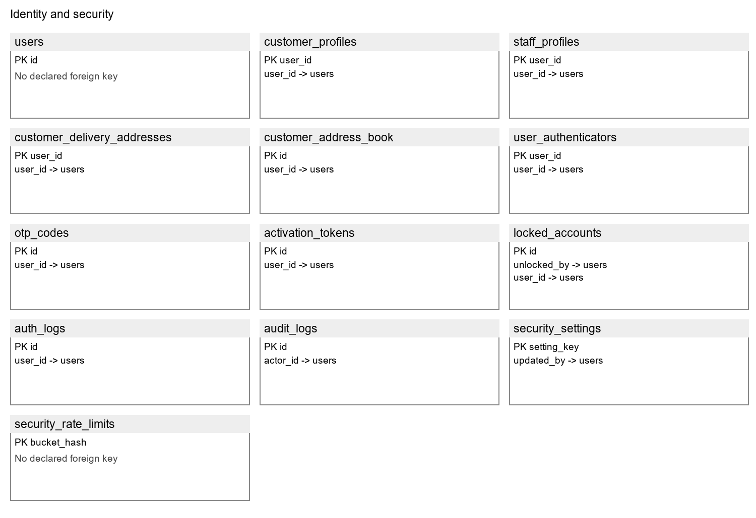
Figure 1. Identity and security schema map, generated from the inspected database metadata.
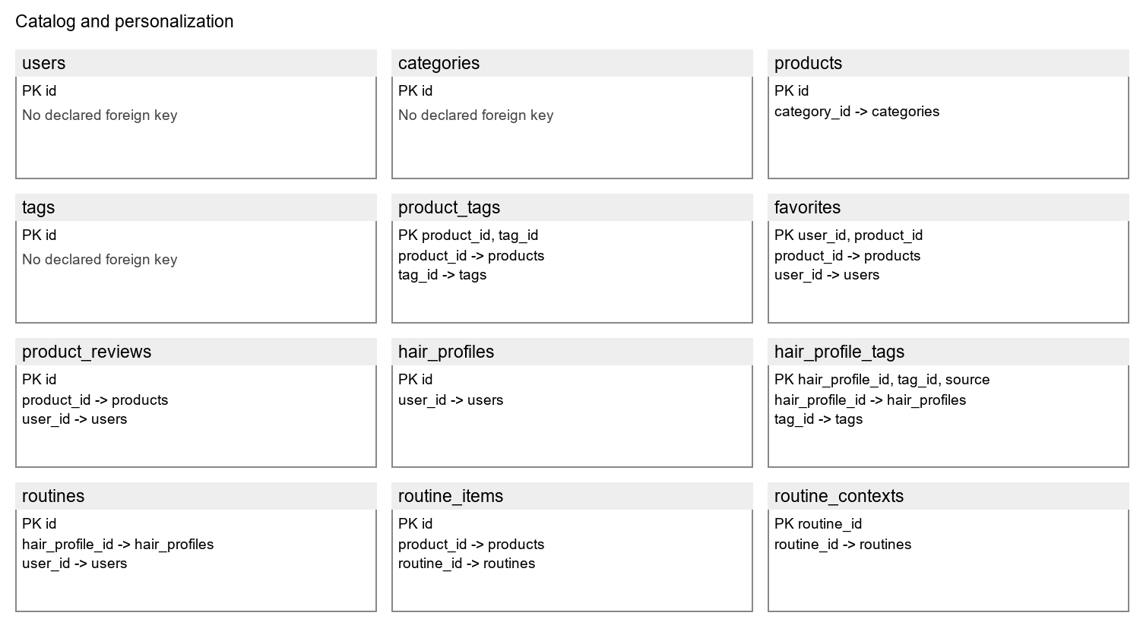
Figure 2. Catalog and personalization schema map, generated from the inspected database metadata.
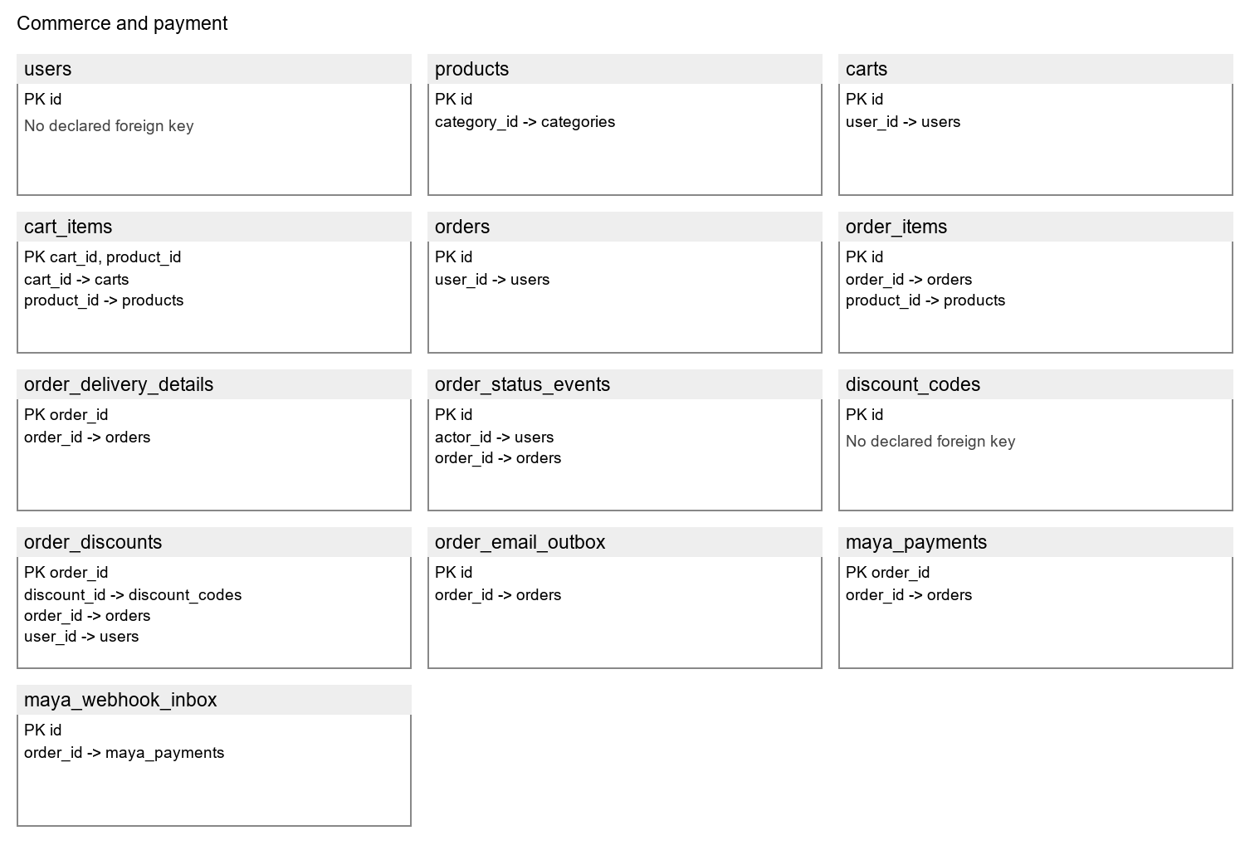
Figure 3. Commerce and payment schema map, generated from the inspected database metadata.

Relationships and Integrity
• users extends to customer_profiles, staff_profiles, user_authenticators and customer_delivery_addresses through user_id. customer_address_book supports multiple encrypted addresses per owner.
• categories relates to products; product_tags and hair_profile_tags associate catalog/profile records with reusable tags. favorites joins users and products with a composite key.
• carts contains cart_items; orders contains order_items and status events. Price/name/recipient snapshots preserve what was ordered even if the catalog or delivery address later changes.
• routines relates to a user and hair profile; routine_items stores selected products and order, while routine_contexts retains profile/rule fingerprints and explanations.
• maya_payments extends an order, maya_webhook_inbox queues provider events, order_email_outbox tracks receipt delivery and order_discounts records reservation/commit/release state.

Table Descriptions

Accounts and protection
Table | Purpose and principal key
users | Account identifiers, password hashes, roles, activation and lock status. PK: id.
customer_profiles | Customer name, contact details, profile image and selected encrypted PII fields. PK: user_id.
staff_profiles | Staff name, contact and image extension. PK: user_id.
customer_delivery_addresses | Legacy structured delivery address and revision token. PK: user_id.
customer_address_book | Multiple owner-bound encrypted address payloads and revision state. PK: id.
user_authenticators | Encrypted TOTP secret, hashed recovery codes, replay step and credential version. PK: user_id.
otp_codes | Hashed one-time email proofs, purpose, expiry and attempt state. PK: id.
activation_tokens | Digests of expiring, single-use activation links. PK: id.
locked_accounts | Account lock history, failure count and unlock actor/time. PK: id.
auth_logs | Authentication outcomes, actor, IP/client metadata and timestamp. PK: id.
audit_logs | Actor, action, target and business-change details. PK: id.
security_settings | Administrator-controlled policy values and update actor. PK: setting_key.
security_rate_limits | Persistent throttling buckets, attempt counts and expiry. PK: bucket_hash.

Catalog and haircare
Table | Purpose and principal key
categories | Product grouping and active/inactive status. PK: id.
products | SKU, category, price, stock, image, routine role and lifecycle state. PK: id.
tags | Reusable texture, scalp, condition and concern vocabulary. PK: id.
product_tags | Product-to-tag associations. PK: product_id, tag_id.
favorites | Customer-to-product saved favorites. PK: user_id, product_id.
product_reviews | Customer product ratings, review text and moderation state. PK: id.
hair_profiles | Structured assessment, treatments, optional text and timestamps. PK: id.
hair_profile_tags | Assessment/NLP tag provenance for a hair profile. PK: hair_profile_id, tag_id, source.
routines | Routine owner and associated hair profile. PK: id.
routine_items | Ordered products and care roles in a stored routine. PK: id.
routine_contexts | Profile/rules version, plan fingerprint and explanation snapshot. PK: routine_id.

Shopping and fulfillment
Table | Purpose and principal key
carts | Customer bag lifecycle. PK: id.
cart_items | Product quantities within a cart. PK: cart_id, product_id.
orders | Buyer, delivery/contact snapshots, payment method, totals, reference and checkout idempotency key. PK: id.
order_items | Historical product, quantity and unit-price snapshots. PK: id.
order_delivery_details | Structured destination, shipping method and fee snapshot for an order. PK: order_id.
discount_codes | Discount definition, eligibility limits, schedule and revision. PK: id.
order_discounts | Applied discount snapshot and redemption reservation state. PK: order_id.
order_status_events | Actor-attributed order-state timeline. PK: id.
order_email_outbox | Queued receipt delivery, attempts, errors and sent timestamp. PK: id.
maya_payments | Provider checkout/reference, amount, verification and stock reservation state. PK: order_id.
maya_webhook_inbox | Payment events queued for leased, repeat-safe processing. PK: id.

Data Dictionary Notes
Identifiers use integer keys or explicit composite keys; account names and references use bounded character columns. Prices use fixed-point decimal values, while discount/payment calculations also use integer cents. Foreign keys preserve parent-child integrity. Revision, profile-version and credential-version fields are concurrency/security tokens, not display timestamps. Postal codes and telephone numbers remain character data so leading zeros and international formatting are preserved.
The supplied group data dictionary and ERD were consulted as references. Their older schema coverage does not include every current encryption and address-book addition; the installed metadata is authoritative for this document. Ingredient reference data and reviewed suitability evidence are maintained in versioned JSON manifests associated with the SKU, not inferred from a missing database ingredients column.

V User Interface Design
Avela uses warm porcelain surfaces, cocoa text, restrained taupe accents, locally hosted typography and photographic product presentation. Customer pages prioritize shopping and readable assessment steps; staff pages prioritize compact forms, lists, validation and operational clarity. Shared layouts provide consistent navigation, account identity, feedback and responsive spacing.
Role | Principal interfaces
Customer and guest | Home, Shop, Product, Search, Favorites, Login/Register, Help and policies; authenticated Profile, Assessment/Hair Profile, Recommendations, Routine, bag/Checkout, Orders and Account Settings
Catalog Manager | Dashboard, Products, Categories, Inventory, profile and authenticator settings
Administrator | Dashboard, users/staff, order oversight, catalog access, security controls, locks and protected activity/audit views

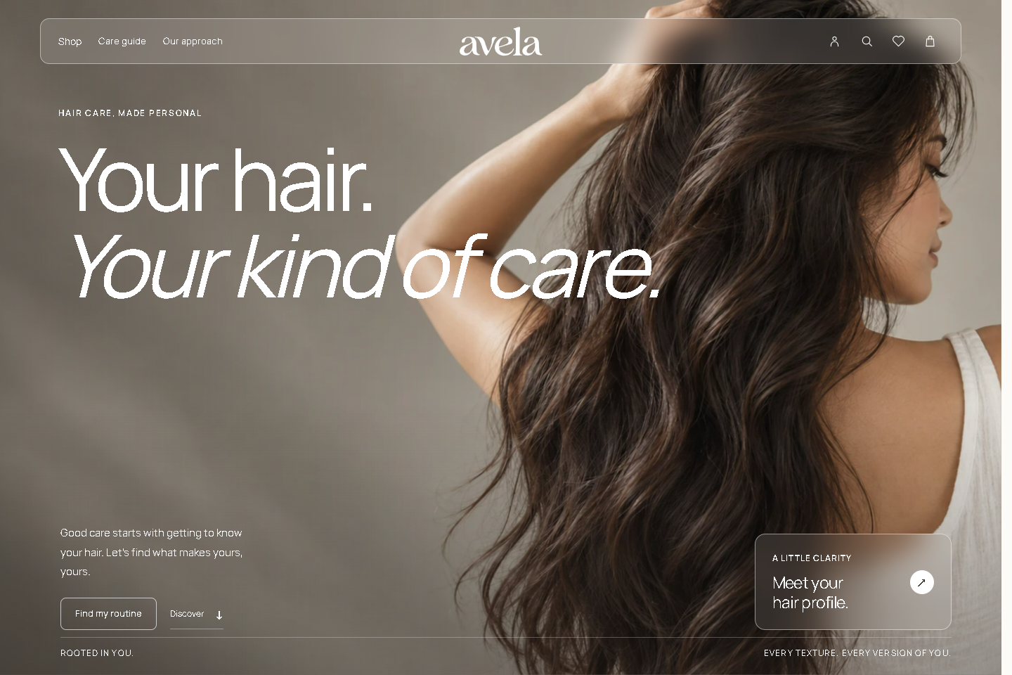
Figure 4. Deployed customer homepage captured through the public HTTPS endpoint.
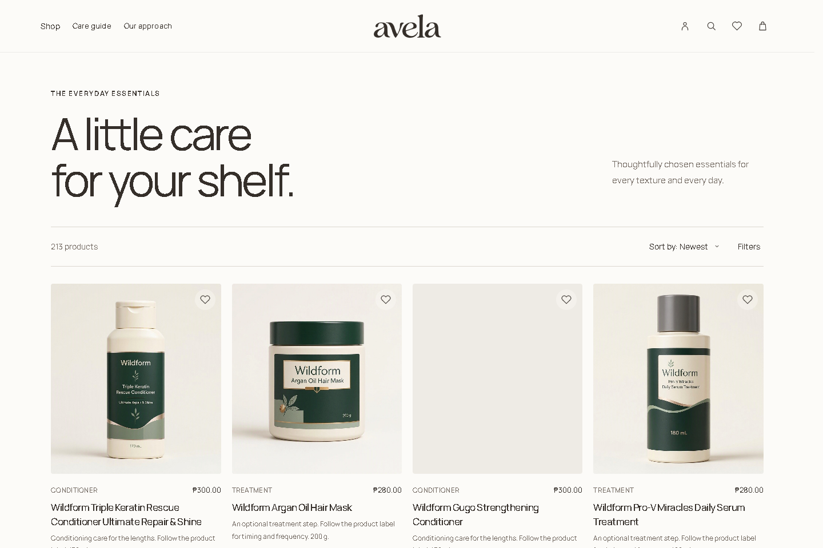
Figure 5. Deployed catalog showing the 213-product inventory count and shared shopping controls.
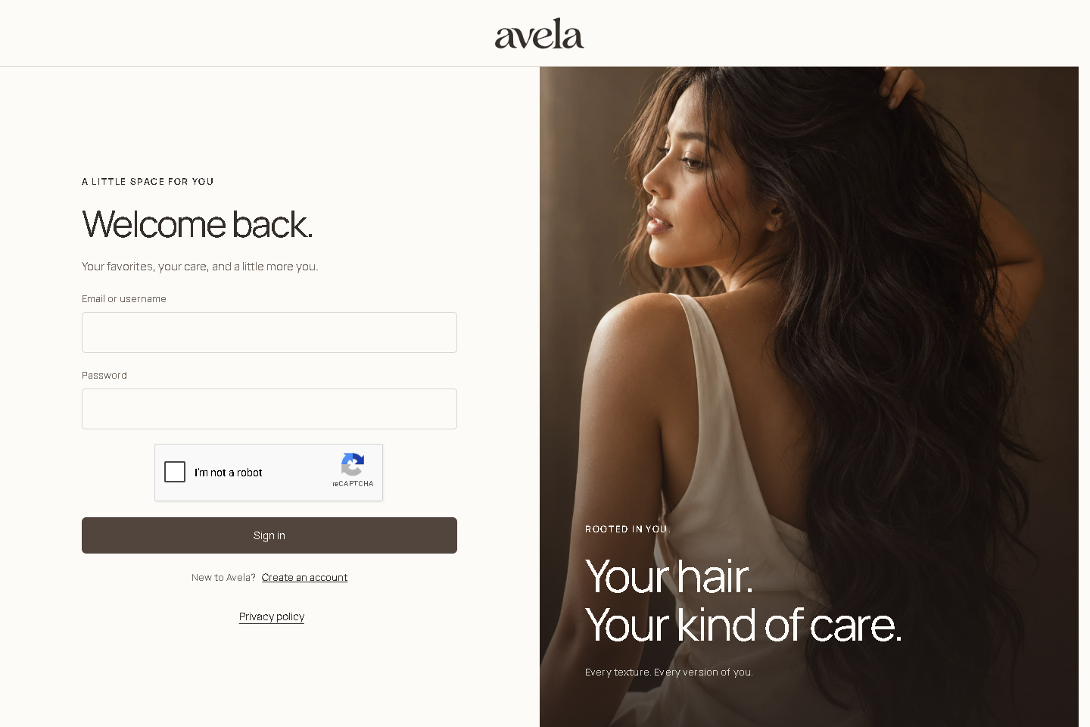
Figure 6. Deployed sign-in interface. No credentials or authentication challenge were submitted.
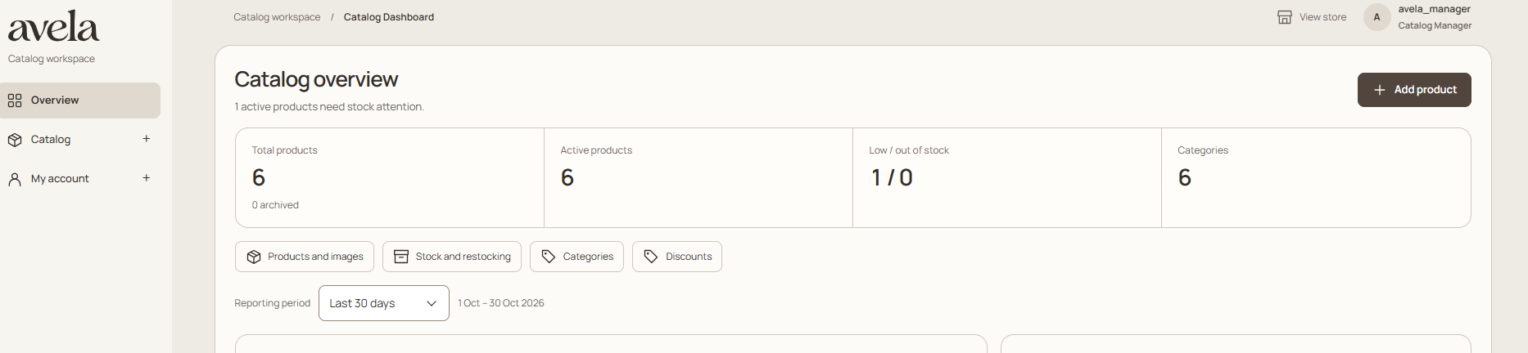
Figure 7. Catalog Manager dashboard reference supplied by the team; shown as interface documentation, not a fresh authenticated deployment test.
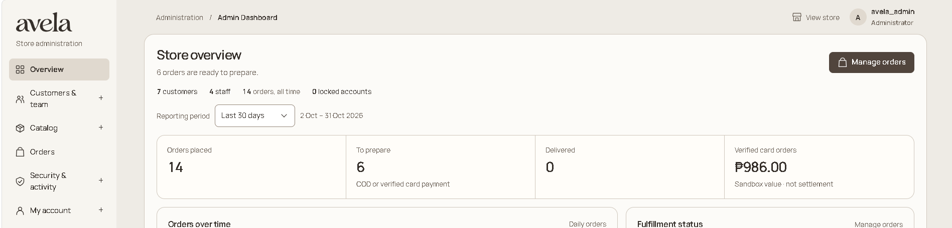
Figure 8. Administrator dashboard reference supplied by the team; sensitive record lists are omitted.

Interaction and Accessibility
The bag is a drawer rather than a duplicate shopping-bag workflow. Filters slide from the right; search and account dialogs manage focus and provide close/Escape paths. Native form controls retain server validation beneath their styled presentation. Assessment choices show selection, step progress, Previous navigation and a review screen. Existing answers remain unchanged until saving succeeds. Password fields provide visibility controls and requirement feedback. Reduced-motion behavior, keyboard focus, responsive layouts and readable feedback are part of the interface implementation; a complete independent accessibility certification is not claimed.

VI Security and Non Functional Requirements
Area | Implemented control and boundary
Authentication | Password hashing with password_hash/password_verify; reCAPTCHA verification; expiring hashed email proofs and single-use activation tokens. Customer activation currently continues to the signed-in homepage.
Authenticator | Google Authenticator-compatible TOTP with replay protection and one-use recovery codes. Setup requires proofs; secrets use authenticated encryption. Enrolled staff require TOTP/recovery; unenrolled staff retain password sign-in until enrollment.
Password and lockout policy | Server-enforced complexity, minimum length, expiry and account/session version checks. Default lock threshold is three attempts; administrators can configure the supported policy range.
Access and requests | Role checks, owner-scoped queries, CSRF tokens, input allowlists, output escaping, prepared statements and persistent request throttling.
PII and keys | AES-256-GCM protects selected profile/order phone/address fields; address-book payloads are encrypted. Names, email and some legacy structured fields remain outside that scope. Keys remain outside Git/public files.
Sessions | Timeout, session renewal/version checks and logout handling. Secure-cookie/proxy settings must match the deployed HTTPS environment.
Uploads | Bounded image types, signatures, dimensions and 2.5 MB size policy; generated filenames and upload execution restrictions. Malware scanning is conditional on real host support and acceptance.
Order consistency | Server prices, transaction boundaries, stock checks/reservations, version tokens, idempotency, guarded discounts and audited cancellation/restoration.
Payment and transport | Maya-hosted Sandbox isolates card entry. HTTPS public pages were reachable; redirect enforcement, DB TLS and genuine webhook/payment acceptance need separate operational verification.
Activity evidence | Authentication outcomes, actor-attributed CRUD audit trails, protected staff views and private technical logs. Logs must not disclose passwords, OTPs or encryption keys.

Verification Results
The completed local regression review recorded 958 passing checks and zero final failures across 22 selected suites. These cover synthetic HTTP/PDO integration, pure matching and encryption logic, controlled process/transport fixtures and DOM simulations. The handoff snapshot subsequently passed 124 focused matching, routine, assessment and encryption checks and syntax validation for 299 PHP and 32 JavaScript files. These results are not claims of 958 browser tests or genuine payment/email delivery.
Public deployment checks retrieved the homepage, Shop and Login over HTTPS with HTTP 200. These read-only checks did not log into customer or staff accounts, place orders or access the hosted database. Local schema counts and catalog verification do not establish that every deployed database migration, worker, provider credential or uploaded image is configured correctly.

Operational Acceptance Items
• Complete a fresh-device database restore and verify existing encrypted profile and authenticator access with the original keys.
• Verify real registration/activation, email-change proof, receipts, staff authenticator enrollment, CAPTCHA hostnames and session timeout on the deployed host.
• Verify current supported PHP/database releases, HTTPS redirects, proxy handling, secure cookies, private secrets, upload restrictions/scanning and scheduled workers.
• Keep Maya in Sandbox and readiness controls conservative until provider verification, event processing, reconciliation and stock release are demonstrated.
• Clarify the IAS activation-to-login wording against the implemented homepage continuation, and the hardcoded/configurable lockout wording against the default three-attempt policy.
• Review final privacy/terms/contact obligations and consent expectations. A written policy is not proof of legal compliance or a complete optional-cookie consent system.

VII Conclusion
Avela brings the customer shopping journey, hair assessment and staff maintenance workflows into one PHP/MySQL application. Its strongest distinction is the connection between structured profile answers, explainable product matches and a practical suggested routine. Transactional stock/order handling and layered account protection support the commerce workflows without replacing them with static preview data.
The implementation is suitable for coursework review with the stated evidence and limitations. Public availability is established for the checked pages; complete operational readiness still depends on destination restoration, authenticated role walkthroughs and real external-service acceptance. New catalog entries should join matching only after suitability evidence is reviewed.

VIII References
Avela application source and feature documentation. https://github.com/aleckzandrabahillo/PHP_Group02_Project. Controllers, services, views, migration scripts, tests and docs reviewed for this report.
Avela public application. https://avela.onrender.com/. Public homepage, catalog and sign-in inspected for this submission.
Group 02 reference folder. https://drive.google.com/drive/folders/1c8GTdvo7h9VHlQIMRVxFvXrCThMy3NRj. Data Dictionary, ERD, interface mockups and Gantt chart; discrepancies were checked against the implementation.
PHP Manual. https://www.php.net/manual/en/. PDO, password hashing, OpenSSL and session facilities used by the application.
MySQL Reference Manual. https://dev.mysql.com/doc/refman/8.0/en/. Relational constraints and transactional storage concepts.
Google reCAPTCHA documentation. https://developers.google.com/recaptcha/docs/verify. Server-side challenge verification.
Maya Developer Hub. https://developers.maya.ph/. Hosted checkout and Sandbox integration reference.
PHPMailer project. https://github.com/PHPMailer/PHPMailer. SMTP email library; OTPHP project. https://github.com/Spomky-Labs/otphp. TOTP library.

IX System Turnover
Deliverable | Location or handling
Live URL | https://avela.onrender.com/
Source code | https://github.com/aleckzandrabahillo/PHP_Group02_Project — main branch
Technical documentation | This completed document and the focused feature/security guides in docs/
Presentation and supporting material | The supplied Drive folder contains ERD, mockups, dictionary and schedule. No presentation deck was supplied in that folder; the team must attach its final defense presentation separately.
Private database and configuration | Transfer separately through an encrypted package. Never place database dumps, .env, uploads containing personal data, sessions, mail logs or original encryption keys in GitHub.

Installation and Recovery
Clone the repository into a new folder and restore locked Composer dependencies. Configure PHP extensions, MySQL/MariaDB and Python. For a new empty installation only, follow README and each guarded migration; the base installer must not be run over existing records. Import the current catalog through the documented refresh/expansion previews and exact target guards, or restore the approved complete private database into a verified empty destination.
For an owner-data transfer, retain the original MFA and PII keys and point the new private environment to its actual database and Python/keyring paths. Do not regenerate keys for encrypted records. Restore approved uploads separately, verify service permissions and start the local server with php -S localhost:18080 -t public router.php. A clone alone does not copy accounts, stock changes or orders. The documented handoff archive passed authenticated decryption and file-hash checks; restoration on the receiving device remains an acceptance task.

Demonstration Sequence
• Open Home and Shop; demonstrate search, filters, product details, favorites and stock-aware bag updates.
• Register and verify a synthetic customer, then show sign-in, profile/address editing and account security without displaying secrets.
• Complete the five-step assessment; explain recognized text signals, reviewed match reasons, missing-match behavior and the suggested routine.
• Place a synthetic COD order in the approved demonstration environment; show totals, receipt, order timeline and staff fulfillment. Demonstrate Maya only in the configured Sandbox.
• Show Catalog Manager product/category/inventory controls, then Administrator role restrictions, account locks, audit trails and dashboard reports.
Acceptance should use synthetic demonstration accounts and agreed role credentials provided privately. Keep the previous installation intact until restoration and the role walkthrough are complete.

